BOARD OF DIRECTORS MEETING AGENDA
August 19, 2025 - Virtual
7:30am – 9:30am

Invitees: Beth Shartle, Alyssa Gombach, Cherie Terrey, Michael Holcombe, Kathy Dale, Bob Ames, Debbie Ramsey, Krista Pauley, Susan Kelly, Denise Lee, Wendy Button, Nic Thomas, Ramona Wolf, Benjamin Lewis, Tamara DeLoretta, Alex Goodman, Susanna Fultz

In attendance: Michael Holcombe, Ramona Wolf, Cherie Terrey, Alyssa Gombach, Nic Thomas, Kevin Moore, Kathy Dale, Wendy Button, Alex Goodman, Bob Ames

- Call to order (Cherie) Cherie called the meeting to order at 7:31

- Approval of Treasurer’s Reports – July 2025 reviewed by Kathy. Motion to approve by Michael, 2nd by Ro. Motion carried.
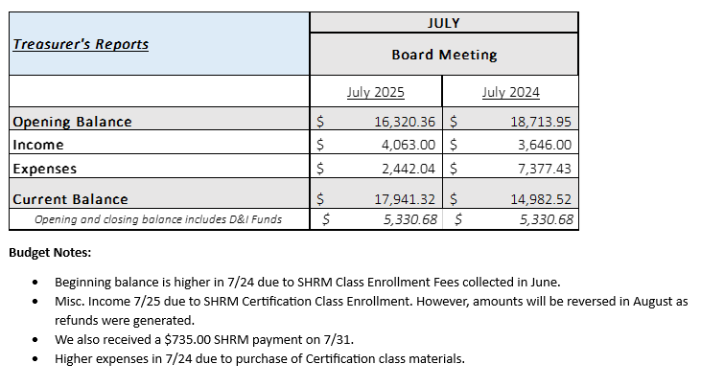

Approval of Minutes: motion to approve made by Kathy, Alysssa 2nd. Motion carried

  - July 8, 2025 General Meeting

  - July 22, 2025 BOD Planning Meeting

- Review of Speaker Critique Summary 10 people did critique out of about 40 who attended
  - July 29, 2025 - “Keeping Humanity at the Core of Leadership – Because People Follow People, not Titles!” presented by Corey Crapella from CORE Coaching & Consulting.
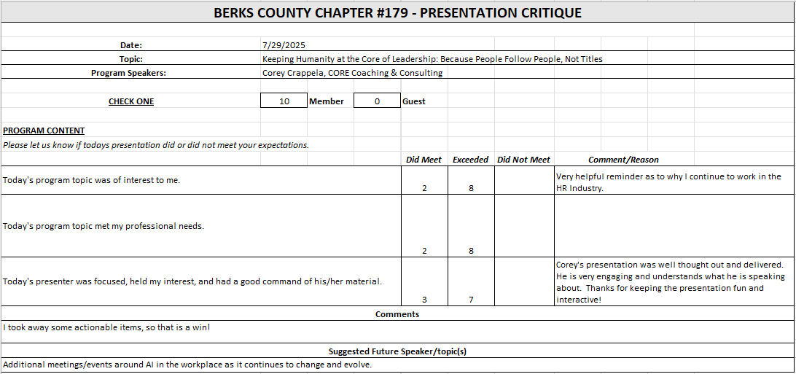
  - August 12, 2025 - “Navigating the Future: Insights and Innovations in Employee Benefits for 2025 & 2026” presented by Sophie Appler & John Patterson from Marsh McLennan Agenc

Close to 50 registered, 26 responses for critique. Mostly positive despite breakfast snafu
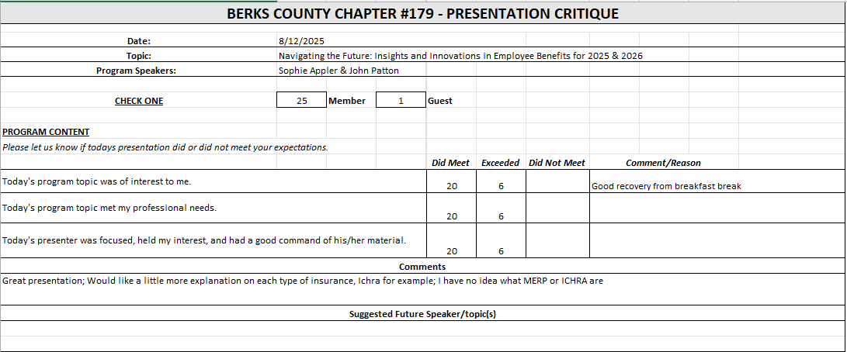

- Committees and Chair Reports:

- Administrator – Website (Wendy Button) No updates on Website. Will update speaker list that Krista sent out
- BCTV (Benjamin Lewis)
- Certification – Study Group (Ramona Wolf & Bob Ames) Ro reiterated that we are not having the study group for he fall. Bob and Ro met with publisher rep and all materials are changing for 2026. Ro has decided to step down now since there is no class running for the fall and is turning the Chair position over to Bob. Ro will be around for questions. We will pass Ro’s registration on to Bob. Cherie will work with Ro to coordinate that transiion. Cherie thanked Ro for her service over the past few years.
- Chapter of the Year (Susan Kelly) – no report
- Compliance (Susan Kelly) – no report
- DEI (Diversity, Equity & Inclusion) (Denise Lee) – no report
- Engagement Committee/Marketing (Nic Thomas) - Happy hour went well and showed how well we can work and draw people together with a sponsor. Cherie noticed many people trying to get new business from us as HR professionals – worried that might turn people away. Kevin thought it was a great idea and likes the idea of a normal happy hour by ourselves as well. Cherie likes both ideas. Kevin says Barley Snyder could sponsor a happy hour. Nic suggested a mix of both is a good idea and we should settle on rules for sponsorship moving forward. Alex spoke to Nic after the mixer… said businesses aren’t always aware of what SHRM does. It might be nice to invite other company people like payroll, controller, etc to introduce them to what SHRM does, our benefits, etc.
- Historian (Benjamin Lewis) – no report
- Membership (Nic Thomas) Nic spoke about our membership applications and it may be confusing for some jobs as to whether someone is doing 50% HR, or even if maybe as an office manager (for example) what is covered as HR functions. Wendy will clarify on our applications. The promo currently running for new national SHRM membership discounts brings money into our chapter if we can recruit new national members. There is a special promo code that Cherie has. Promo runs through the end of the year. Cherie will send an email out with more information.
- Legislative (Susanna/Kevin) Kevin stated that Susanna will take over, but Kevin will fill in as backup as needed. Ongoing litigation through all agencies dealing with employment. New acting secretary is walking back many Biden era laws/rules. Kevin suggests to get on his alert list. Cherie stated that we will not need a report in September because of Andrew Howe presenting, but it is up to him. Kevin said they will plan on doing on for each month regardless. Kevin will present for next May – Kevin just confirmed with Krista.
- A-Team (Alex Goodman) Alex said that her group meets on 9/3. They are putting together a survey on HR hot topics with impact on state level. Goal is to get a ranking as to what the chapter feels we should focus our efforts. She connected with Chamber and would like to have a roundtable with Legislators regarding issues. A-Team will work on making this a reality, depending on topics, they will work towards getting appropriate legislators. She told them about our BCTV forum and the availability to speak about topics there as well They were interested in partnering with us on this. Survey should be a paper survey followed by a monthly survey via Wendy or on the tables at the next meeting.
- Programming / Speaker Contact (Krista Pauley) sent meeting schedule. Has an email out to RACC for march meeting that we spoke about. Will keep us posted as she books more.
- Sponsorship / Business Networking (Tamara DeLoretta) – no report
- Olivet Boys and Girls Club - PAL Dinner or RHS Initiatives (Debbie Ramsey) – no report
- SHRM Foundation (chairperson needed) – no report
- Old Business
  - Update on Chapter By-Laws review (Alyssa) Alyssa spoke to Theresa from SHRM national. She will help us out, however SHRM prefers that all chapters use their template. Alyssa will need to revise everything to match the template. She will begin working on it later in the fall and will send out for review once that is done later this year. Also – regarding insurance requirements for chapter – on 2026 SHRM reports for 2025, it will ask about proper coverages. If we answer “no” for the new required coverages, we will not be penalized for 2025. SHRM is looking for umbrella coverages for chapters to use going forward, so we are okay for now. This is not a guarantee, but what we have been told verbally. Cherie asked if we want to move forward or to hold off based on this news? Alyssa is not opposed either way. Cherie assumes we would need a new quote, so she is fine with waiting for now as we are getting close to the end of the year.
  - Credit Card Processing Company Review (Michael) nothing new yet
  - Liability insurance policy review (Cherie & Nic)
    - $1,000,000 liability limit = $1,067/year premium
    - $500,000 liability limit = $872/year premium
SHRM Affiliate Standards Program Requirements: Dual Membership Requirements (President, Membership Director, Certification Director), basic Directors & Officers (~$840 annually), Errors & Omissions (~$750 annually), and Cyber Liability (~$500-$2,000 annually) insurance, completion of regular financial audits (every 3-5 years)
  - Wireless microphone (Bob) – Bob checked out the system at the country club. They use an Audix system which is designed to use proprietary mics. It would cost us between $500-$800 for the mic we want, but it would only work on that system. Bob suggested we may want to spend similar money on a portable PA system that is self-contained – includes amplified PA speaker, wireless mic, and is something we would own and be able to use anywhere. Agreed that Bob would gather recommendations for these systems and bring to the next board meeting to present.
  - Mentorship program – Young/ Emerging Professionals (Michael) Michael attended call. Model works for large city markets (NYC). Michael feels that this was tailored towards chapters with many new-to-profession HR professionals looking for mentorship. He feels that this is not something that fits in our market. There is a follow-up call coming where we can get more information if interested. Cherie asked if this is something we would be interested in. Nic has met some people that feel that they don’t get the internal support from their own companies but not form lack of interest from individuals and their interest in SHRM. Cherie said that maybe we can support them with an unofficial mentorship capacity to encourage people to come to local meetings and participate and get connected to individuals. Alyssa said this is something that the engagement committee could take on and be involved in creating a buddy system to help integrate people into our local chapter.
  - Meeting Sponsorship Update (Wendy) Did we finalize the “buy1- get 1” sponsorship deal? Wendy sent it out and Cherie had some thoughts about it but doesn’t recall seeing many other comments on it. Much discussion was held about various options. We don’t have sponsors beating down our doors. Should be speak to Tamara and see if price is an issue when she is discussing sponsorships with vendors? This would affect what we decide as to pricing or bundling options. Proposal by Alyssa – bundle for in person & virtual $350, repeat sponsorship get $50 discount. Group consensus is to wait for input from Tamara before we make a decision on this or make additional changes. We will revisit this next month.

- New Business:
  - Facebook “Boost” Cost (Wendy) Facebook utilizes algorithms to target HR professionals so that our page comes up as a sponsored page that they may want to follow for a $5/day fee. Can generate more interest in the chapter events. 29 followers so far but they are all members of our chapter. Our goal is to get people from outside of the chapter to engage in our page. Kathy proposed 1 week ($35) as a test – motion by Alyssa to post for 7 days, Michael 2nd. Cherie asked how we pay, Wendy pays and chapter will reimburse. Motion carried.
$5.00 per day, Facebook estimates we can reach between 281 – 815 HR professionals – gain followers
Run for as little or as many days as we’d like
  - Affiliate Membership Drive (Nic) nic had to drop off of the call
  - Email came through on Friday – SHRM is changing the way affiliate websites are hosted. Their will be a single sign on for more seamless flow of info. However – chapters must be DMR (dual membership release). We need to decide by the end of the year. We would also need to be cobranded. Alyssa said she doesn’t think that there is a cost for cobranding. Other option per email is that we can find our own website host – SHRM will continue to support our site through June during a transition to another host. Alyssa noted that there is a DMR specialist at SHRM that we could meet with to further explain what DMR means for a chapter and whether it is worth it or not for us with financial support, etc.
Cherie clicked on the link in the email and there is more information on DMR program. She will forward out to the whole board so that we can discuss more next month and make a timely decision.

- Future Berks, PA and National SHRM meetings/dates:
* State Council meetings available to Executive Board, District Directors, Chapter Presidents and Core Leaders
* VLBM invitees: Chapter President & President-Elect invited . SHRM National covers cost of hotels, meals, and transportation between hotel/airport.
  - September 9, 2025 – General Meeting (Berkshire Country Club) – 7:30 a.m. to 9:00 a.m. – “Annual Legal and Legislative Update” - Andrew Howe from Dinsmore.
  - September 10, 2025 – Q4 PA SHRM State Council Meeting – State College, PA – 1:00 p.m. to 5:00 p.m.
  - September 11-12, 2025 – Annual Conference – Penn Stater Hotel & Conference Center, State College, PA
  - September 23, 2025 – Lunch and Learn (Microsoft Teams) - 11:30am to 12:30pm - “Sextortion and Human Trafficking Awareness” - Jeffrey Reichart from Governor Mifflin School District.
  - November 20-23, 2025 – Volunteer Leaders Business Meeting (VLBM) – Cancun, Mexico
  - February 2026 – Q1 PA SHRM State Council Meeting – Virtual – 9:00am – 11:00am
  - May 2026 – Q2 PA SHRM State Council Meeting - TBD - 1:00 pm – 5:00 pm
  - May 2026 – PA SHRM Legal & Legislative Conference – TBD
  - June 16–19, 2026 – SHRM Annual Conference - Orland, FL or virtual
- Deadlines
  - August 1, 2025 – Chapter of the Year (COTY) (Susan)
  - September 1, 2025 - Pinnacle Award Application
  - November 15, 2025 – Re-Certification Provider Reaffirmation Due (Chris)
  - December 1, 2025 – CLIF report (Wendy)
  - December 31, 2025 – SHRM Foundation annual donation (Treasurer)
  - January 31, 2026 – Deadline to issue 1099 (Treasurer to work with RKL)
  - January 31, 2026 – SHAPE (“SHRM Affiliate Standards Program”) report (VP)
  - March 15, 2026 – EXCEL Award (VP)
  - April 15, 2026 – Annual Statement – PA Dept. of State – Bureau of Corporations and Charitable Organizations – 990-N (e-postcard) to the IRS (Susan)

- Next Board Meeting – September 16, 2025 – 7:30am - 9:00am via Teams

- Motion to adjourn – motion to adjourn made at 9:01 by Michael, 2nd by Alex.

