BOARD OF DIRECTORS MEETING AGENDA
June 17, 2025 (virtual)
7:30 a.m. to 9:00 a.m.

Invitees: Chris Holmes, Beth Shartle, Alyssa Gombach, Cherie Terrey, Michael Holcombe, Kathy Dale, Debbie Ramsey, Krista Pauley, Whitney Rahman, Susan Kelly, Denise Lee, Wendy Button, Nic Thomas, Ramona Wolf, Benjamin Lewis, Tamara DeLoretta, Alex Goodman, Bob Ames
Highlighted=Attended
- Call to order (Cherie) @ 7:33 AM

- Approval of Treasurer’s Reports – May 2025 Deposits not made until June due to timing of training.

Motion to Approve: Alyssa Gombach, 2nd: Michael Holcombe; All in Favor
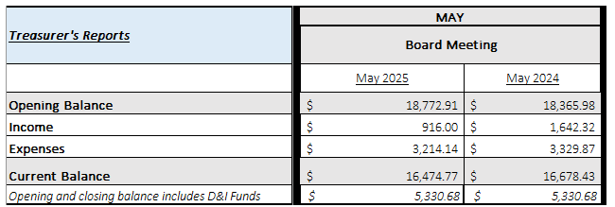

Approval of Minutes:

  - May 13, 2025 General Meeting Motion to Approve Michael Holcombe; 2nd Alyssa Gombach; All in Favor
  - May 20, 2025 BOD Meeting Motion to Approve: Michael Holcombe; 2nd Krista Pauley; All in Favor

- Review of Speaker Critique Summary
  - May 27, 2025 - "Investing in Employee Wellbeing for Today and the Future" - John Benson, Willis Towers Watson
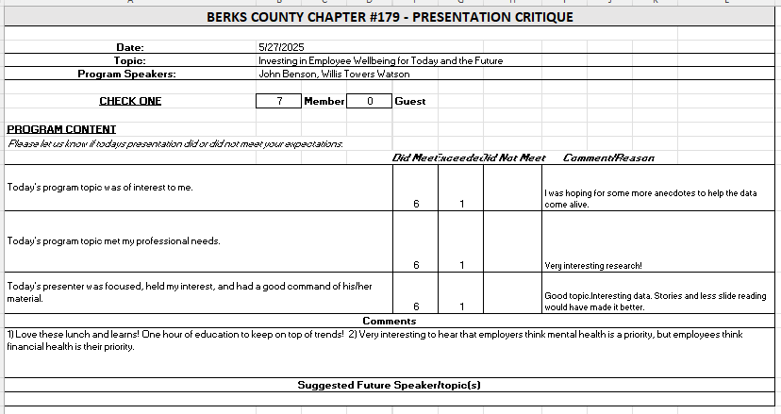
  - June 10, 2025 - “National Incident Management System (NIMS) for Emergency Operations Teams” - Cory Fairman, The Fatula Group
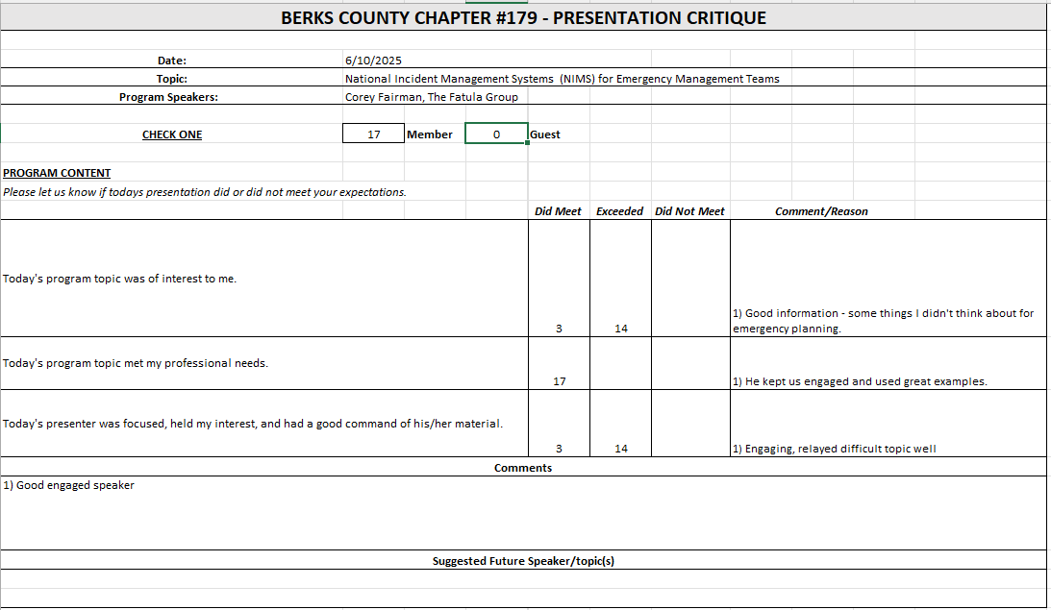
- Committees and Chair Reports:

- Administrator – Website (Wendy Button) Not Present
- BCTV (Benjamin Lewis) July Program will be a recruiting topic; Looking to have Chamber of Commerce on September program; Background Checks as topic in October.
- Certification – Study Group (Ramona Wolf & Bob Ames) Not Present
- Chapter of the Year (Susan Kelly) Not Present
- Compliance (Susan Kelly) Not Present
- DEI (Diversity, Equity & Inclusion) (Denise Lee) Will reach out to current committee members to confirm continuing interest and then will set up a meeting to restart.
- Engagement Committee/Marketing (Nic Thomas) Not Present
- Historian (Benjamin Lewis) No Updates
- Membership (Nic Thomas) Not Present
- Legislative (Whitney Rahman) Whitney is retiring and will no longer be presenting the Legislative Updates after July. Discussed other speakers who could possibly step in. Cherie will reach out to Kevin.
- A-Team (Alex Goodman) Alex has built a committee. Next step is to survey members to gage topic interests.
- Programming / Speaker Contact (Krista Pauley) Update was sent yesterday (6/16). We are set for next 3 lunch and learns and for the general meetings through January.
- Sponsorship / Business Networking (Tamara DeLoretta) PA Ren Faire reached out to request to sponsor.
- Olivet Boys and Girls Club - PAL Dinner or RHS Initiatives (Debbie Ramsey) Not Present
- SHRM Foundation (chairperson needed)

- Old Business
  - Update on Chapter By-Laws review (Alyssa) By-Laws were uploaded; Alyssa is waiting for response and will reach out to SHRM in a few weeks if we do not hear back.
  - ½ Day Workshop Suggestion (Krista, Denise, Tamara, and Alyssa) – Judy Umlas / DEI/ RACC No updates at this time; pending committee meeting which will be scheduled at a later date.
  - Credit Card Processing Company Review (Michael) No update; project on hold at this time.
  - Updating job descriptions – added key events/conferences Cherie will resend job descriptions for final review and comments.
  - Liability insurance policy review (Cherie & Nic) No update; pending confirmation of SHRM requirements.
    - $1,000,000 liability limit = $1,067/year premium
    - $500,000 liability limit = $872/year premium
  - SHRM Affiliate Standards Program Requirements: Dual Membership Requirements (President, Membership Director, Certification Director), basic Directors & Officers (~$840 annually), Errors & Omissions (~$750 annually), and Cyber Liability (~$500-$2,000 annually) insurance, completion of regular financial audits (every 3-5 years) No update pending confirmation of SHRM requirements.
  - 2025 Annual Membership Survey Will ask Wendy to share results at next BOD meeting.

- New Business:
  - Discuss reimbursement strategy for this year’s VLBM in Cancun, Mexico VLBM was held in D.C. in past and attendee was reimbursed for mileage and parking expenses. However, this year a flight is involved. Ideas shared:
- Reimburse mileage and parking at airport and set stipend for airfare.
- Ask for company sponsorship for trip.
- Ask members for support.
- Full reimbursement subject to Board approval
Decided to table discussion for now and revisit.
  - Berks County Workforce Development Board (in partnership with TPMA) is requesting our help with a survey on hiring trends and workforce challenges. Agreed not to share survey with members; It does not appear that survey results will be shared so there is no benefit to members.
  - Larry Booker from PA Dept of Treasury would like to provide a list of unclaimed money belonging to member organizations, but he would need organization names. This is for the July 8th presentation. Agreed to not provide list ahead of time; Presenter can have sign up sheet at meeting if employers are interested.
- Future Berks, PA and National SHRM meetings/dates:
* State Council meetings available to Executive Board, District Directors, Chapter Presidents and Core Leaders
* VLBM invitees: TBD, but most likely the 2026 Chapter President only. SHRM National covers cost of hotels, meals, and transportation between hotel/airport.
  - June 28, 2025 – July 2, 2025 – SHRM Annual Conference – San Diego, CA
  - July 8, 2025 – General Meeting (Berkshire Country Club) – 7:30 a.m. to 9:00 a.m. – “Title TBD” - Larry Booker, PA Dept of Treasury.
  - July 18, 2025 – Q3 PA SHRM State Council Meeting (Virtual) - 9:00 am – 11:00 am
  - July 22, 2025 – Lunch & Learn (virtual) - 11:30am – 12:30pm -- “Keeping Humanity at the Core of Leadership Because People Follow People Not Titles” - Cory Crapella, CORE Coaching & Consulting.
  - July 25, 2025 – PA SHRM Volunteer Leadership Conference – Gettysburg, PA
  - September 10, 2025 – Q4 PA SHRM State Council Meeting – State College, PA – 1:00 p.m. to 5:00 p.m.
  - September 11-12, 2025 – Annual Conference – Penn Stater Hotel & Conference Center, State College, PA
  - November 20-23, 2025 – Volunteer Leaders Business Meeting (VLBM) – Cancun, Mexico
  - May 2026 – Q2 PA SHRM State Council Meeting - TBD - 1:00 pm – 5:00 pm
  - May 2026 – PA SHRM Legal & Legislative Conference – TBD

- Deadlines
  - August 1, 2025 – Chapter of the Year (COTY) (Susan)
  - September 1, 2025 - Pinnacle Award Application
  - November 15, 2025 – Re-Certification Provider Reaffirmation Due (Chris)
  - December 1, 2025 – CLIF report (Wendy)
  - December 31, 2025 – SHRM Foundation annual donation (Treasurer)
  - January 31, 2026 – Deadline to issue 1099 (Treasurer to work with RKL)
  - January 31, 2026 – SHAPE (“SHRM Affiliate Standards Program”) report (VP)
  - March 15, 2026 – EXCEL Award (VP)
  - April 15, 2026 – Annual Statement – PA Dept. of State – Bureau of Corporations and Charitable Organizations – 990-N (e-postcard) to the IRS (Susan)

- Next Board Meeting – July 22, 2025 – Annual Planning Meeting @ Mimmos beginning at 4pm

- Motion to adjourn @ 8:40 AM; Motion: Alyssa Gombach; 2nd Michael Holcombe

