BOARD OF DIRECTORS MEETING AGENDA
May 20, 2025 (virtual)
7:30 a.m. to 9:00 a.m.

Invitees: Chris Holmes, Beth Shartle, Alyssa Gombach, Cherie Terrey, Michael Holcombe, Kathy Dale, Debbie Ramsey, Krista Pauley, Whitney Rahman, Susan Kelly, Denise Lee, Wendy Button, Nic Thomas, Ramona Wolf, Benjamin Lewis, Tamara DeLoretta, Alex Goodman, Bob Ames
Highlighted = Present

- Call to order (Cherie) @7:33 AM

- Approval of Treasurer’s Reports – April 2025 Motion to Approve: Alyssa Gombach, 2nd Bob Ames, All in Favor

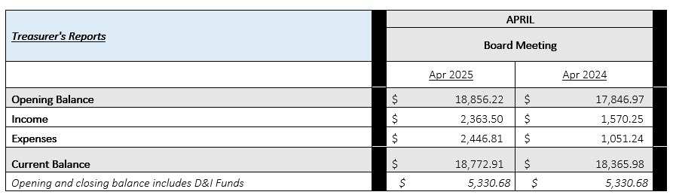

Approval of Minutes:

  - April 8, 2025 General Meeting Motion to Approve: Nic Thomas, 2nd Alyssa Gombach; All in Favor
  - April 15, 2025 BOD Meeting Motion to Approve: Michael Holcombe, 2nd Cherie Terrey; All in Favor

- Review of Speaker Critique Summary

  - "Federal and State Leave Laws and Recent Jury Verdicts Involving Leave Disputes” presented by Susan Simmons; May 13, 2025 General Meeting

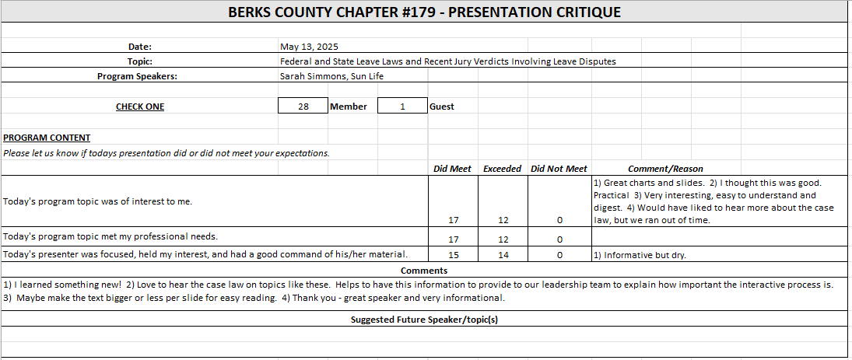

- Committees and Chair Reports:

- Administrator – Website (Wendy Button) Not Present / No Report
- BCTV (Benjamin Lewis) Not Present / No Report
- Certification – Study Group (Ramona Wolf & Bob Ames) No Report
- Chapter of the Year (Susan Kelly) Not Present / No Report
- Compliance (Susan Kelly) Not Present / No Report
- DEI (Diversity, Equity & Inclusion) (Denise Lee) Not Present / No Report
- Engagement Committee/Marketing (Nic Thomas) We had a nice turnout at the May 7th networking event. Discussed concern about not having exposure of new members due to being spread out across different tables. Suggested that we take a moment to make sure new members and present Board members are introduced to everyone. Suggested to have next events sometime in July.
- Historian (Benjamin Lewis) Not Present / No Report
- Membership (Nic Thomas) One new member within last 30 day.
- Legislative (Whitney Rahman) Not Present / No Report
- A-Team (Alex Goodman) Not Present but provided update:
  - Alex plans to schedule a committee meeting for this week to get additional support and ideas for the A-Team.

- Programming / Speaker Contact (Krista Pauley) Recent update was sent on 5/19/25; Waiting to hear from 2 potential speakers.
- Sponsorship / Business Networking (Tamara DeLoretta) Not Present / No Update
- Olivet Boys and Girls Club - PAL Dinner or RHS Initiatives (Debbie Ramsey) Not Present / No Update
- SHRM Foundation (chairperson needed) No Update

- Old Business
  - Update on Chapter By-Laws review (Alyssa) There has been confusion on how to submit the By-Laws for review; Alyssa has received different instructions from different sources and is working to get clarification.
  - ½ Day Workshop Suggestion (Krista, Denise, Tamara, and Alyssa) – Judy Umlas / DEI/ RACC Pending; Had idea to combine RACC’s offering with half-day DEI event but there have been no updates from DEI team; Krista looking to lock down date with RACC for March meeting and then get DEI team involved if they are interested.
  - Credit Card Processing Company Review (Michael) Ongoing; working to transition Treasurer duties to Kathy but plans to remain involved in Credit Card review; Question came up regarding CC processing equipment; Cherie thought it had been returned to bank; Are there charges for the equipment?; Will bank fees be reduced if equipment is returned?; Need to investigate further.
  - Updating job descriptions – added key events/conferences No additional suggestions; looking to finalize over next month.
  - Liability insurance policy review (Cherie & Nic) Pending; waiting on SHRM standards confirmation.
    - $1,000,000 liability limit = $1,067/year premium
    - $500,000 liability limit = $872/year premium
    - SHRM Affiliate Standards Program Requirements: Dual Membership Requirements (President, Membership Director, Certification Director), basic Directors & Officers (~$840 annually), Errors & Omissions (~$750 annually), and Cyber Liability (~$500-$2,000 annually) insurance, completion of regular financial audits (every 3-5 years)
  - 990-N e-postcard filing – was this confirmed complete? Susan Kelly confirmed filing.

- New Business:
  - Scheduling of BOD annual meeting in-person – end of July dates? Mimmos? Discussed dates: Michael away week of 7/16; Bob not available on 7/24; Alyssa not available on Mondays; Looking at week of 7/28; Cherie will send message to rest of Board to check for availability.
  - 2025 Annual Membership Survey Deadline is 5/31; should have results next BOD Meeting
  - PA State Council meeting overview – May 7th (Alyssa) A. SHRM has no updates regarding liability insurance but there was a discussion regarding possible options: 1. Possible main umbrella policy that local chapters can take advantage of, 2. Look into small rider on liability policy, 3. Investigate if 3rd party liability coverage will extend to Chapter protection. B. Career Link has been refreshing their outreach. Is it possible to invite them to present/sponsor a meeting? Nic is on a board and will reach out to Career Link. C. PA Annual Business Report Filing – this was presented as “new” but Alyssa feels that our Chapter is already filing this report annually; she will do additional research to confirm.
  - NEW Reviewed request submitted by member regarding salary BDO survey; Initially discussed including the information in a newsletter but Michael brought up idea to use it as leverage for a sponsorship; Tamara will be asked to reach out to BDO for sponsorship.
- Future Berks, PA and National SHRM meetings/dates:
* State Council meetings available to Executive Board, District Directors, Chapter Presidents and Core Leaders
* VLBM invitees: TBD, but most likely the 2026 Chapter President only. SHRM National covers cost of hotels, meals, and transportation between hotel/airport.
  - May 13, 2025 – General Meeting (Berkshire Country Club) – 7:30 a.m. to 9:00 a.m. – “Federal and State Leave Laws and Recent Jury Verdicts Involving Leave Disputes” presented by Sarah Simmons
  - May 27, 2025 – Lunch & Learn (Virtual) – 11:30 a.m. to 12:30 p.m. – “Investing in Employee Wellbeing for Today and the Future” presented by John Benson
  - June 10, 2025 General Meeting (Berkshire Country Club) 7:30 a.m. to 9:00 a.m. “National Incident Management System (NIMS) for Emergency Operations Teams” presented by Bubba Fatula of The Fatula Group
  - June 28, 2025 – July 2, 2025 – SHRM Annual Conference – San Diego, CA
  - July 18, 2025 – Q3 PA SHRM State Council Meeting (Virtual) - 9:00 am – 11:00 am
  - July 25, 2025 – PA SHRM Volunteer Leadership Conference – Gettysburg, PA
  - September 10, 2025 – Q4 PA SHRM State Council Meeting – State College, PA – 1:00 p.m. to 5:00 p.m.
  - September 11-12, 2025 – Annual Conference – Penn Stater Hotel & Conference Center, State College, PA
  - November 20-23, 2025 – Volunteer Leaders Business Meeting (VLBM) – Cancun, Mexico
  - May 2026 – Q2 PA SHRM State Council Meeting - TBD - 1:00 pm – 5:00 pm
  - May 2026 – PA SHRM Legal & Legislative Conference – TBD
- Deadlines
  - August 1, 2025 – Chapter of the Year (COTY) (Susan)
  - September 1, 2025 - Pinnacle Award Application
  - November 15, 2025 – Re-Certification Provider Reaffirmation Due (Chris)
  - December 1, 2025 – CLIF report (Wendy)
  - December 31, 2025 – SHRM Foundation annual donation (Treasurer)
  - January 31, 2026 – Deadline to issue 1099 (Treasurer to work with RKL)
  - January 31, 2026 – SHAPE (“SHRM Affiliate Standards Program”) report (VP)
  - March 15, 2026 – EXCEL Award (VP)
  - April 15, 2026 – Annual Statement – PA Dept. of State – Bureau of Corporations and Charitable Organizations – 990-N (e-postcard) to the IRS (Susan)

- Next Board Meeting – June 17, 2025 – 7:30 to 9:00 a.m. via Teams

- Motion to adjourn @ 8:15 AM; Motion by Michael Holcombe, 2nd Alyssa Gombach

