BOARD OF DIRECTORS MEETING MINUTES
April 15, 2025 (virtual)
7:30 a.m. to 9:00 a.m.

Invitees: Chris Holmes, Beth Shartle, Alyssa Gombach, Cherie Terrey, Michael Holcombe, Kathy Dale, Debbie Ramsey, Krista Pauley, Whitney Rahman, Susan Kelly, Denise Lee, Wendy Button, Nic Thomas, Ramona Wolf, Benjamin Lewis, Tamara DeLoretta, Alex Goodman, Bob Ames
HIGHLIGHTED = ATTENDEES

- Call to order (Alyssa) @ 7:31 AM

- Approval of Treasurer’s Reports – March 2025 Motion to Approve: Kathy Dale; 2nd Cherie Terrey; No Questions; All Approve

Treasurer's Reports | MARCH
Treasurer's Reports | Board Meeting
 | Mar 2025 | Mar 2024
Opening Balance | $17,689.20 | $16,640.51
Income | $2,585.75 | $2,635.74
Expenses | $1,418.73 | $1,429.28
Current Balance | $18,856.22 | $17,846.97
Opening and closing balance includes D&I Funds | $5,330.68 | $5,330.68

Approval of Minutes:

  - March 11, 2025 General Meeting: Motion to Approve: Ben Lewis; 2nd Cherie Terrey; No Questions; All Approve
  - March 18, 2025 BOD Meeting: Motion to Approve: Michael Holcombe; 2nd Ben Lewis; No Questions; All Approve

- Review of Speaker Critique Summary

  - “AI in HR 2.0: Shaping the Future of Work” presented by Harold Ford on March 11, 2025
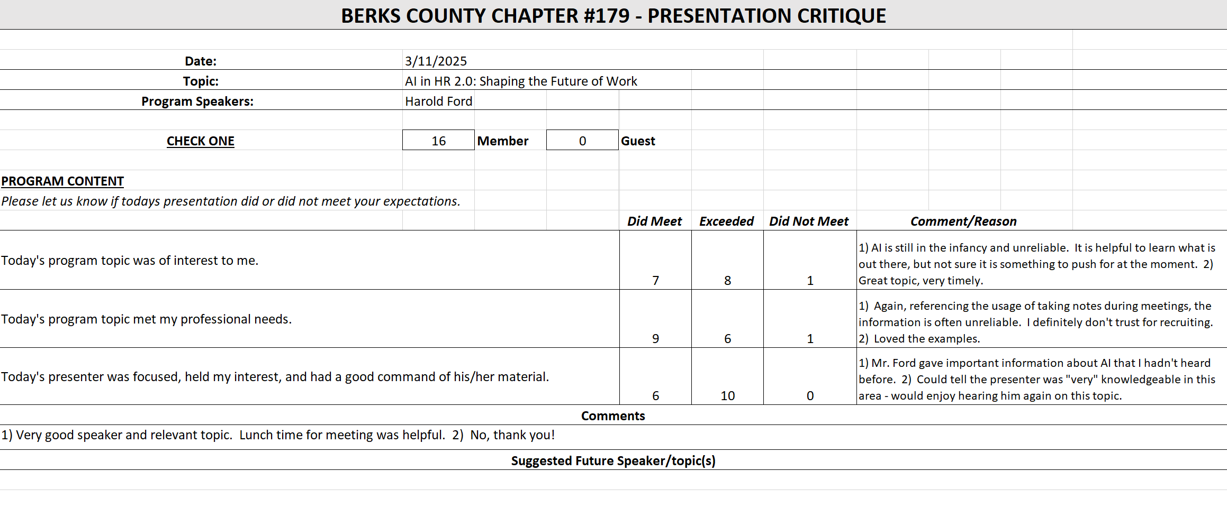
  - “Mental Health Crisis in America - What you Need to Know” presented by Eric Rodriguez on March 25, 2025 (Lunch & Learn)
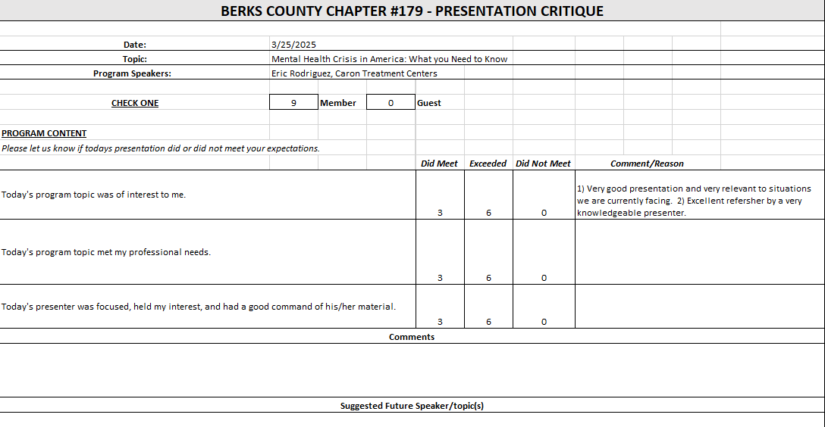
  - “AI in Action: Understanding Its Impact on HR and Beyond” presented by Eric Robuck on April 8, 2025
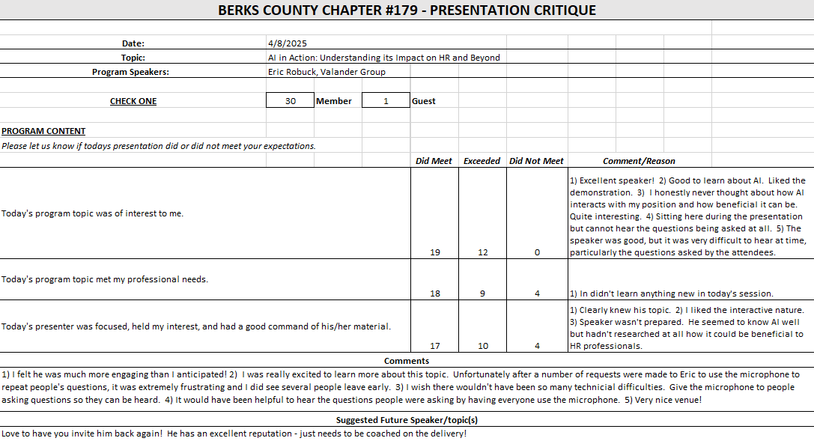

- Committees and Chair Reports:

- Administrator – Website (Wendy Button) No report; Arrived later.
- BCTV (Benjamin Lewis) Taping is scheduled for 5/8; Researching for June episode; July and October topics are scheduled.
- Certification – Study Group (Ramona Wolf & Bob Ames) Bob Ames will take over as Certification Chair after Fall Session; Fall session will start 1st or 2nd week of September; Wendy is going to send out survey.
- Chapter of the Year (Susan Kelly) No Report
- Compliance (Susan Kelly) Alyssa to confirm legal filings are completed.
- DEI (Diversity, Equity & Inclusion) (Denise Lee) No formal updates; Will schedule a committee meeting within next few weeks; Will be on vacation 5/7 – 5/22.
- Engagement Committee/Marketing (Nic Thomas) Next network gathering is scheduled for 5/7 at Beverly Hills Tavern; Invite was emailed on 4/14/25; Idea is to schedule regular networking events with hope that the events gain more interest as time goes on.
- Historian (Benjamin Lewis) No updates
- Membership (Nic Thomas) 2 new members in March which has been the average; reminded Board Members to welcome new members at meetings.
- Legislative (Whitney Rahman) No updates; Asked if she would do the Board Installations again; Alyssa confirmed “yes” and will get script – Wendy may have the script, or it should be listed on Volunteer site.
- A-Team (Alex Goodman) Has meeting scheduled with former chair for training; Already has one volunteer who is interested in serving on committee.
- Programming / Speaker Contact (Krista Pauley) Speakers are scheduled through November; RACC would like to host our group for a session on-site, July 8th is open with RACC. However, we may be already committed to Berkshire; Discussed having RACC host during winter when meetings are virtual but there is a concern with bad weather, etc. Alyssa to check with Wendy regarding the contract with Berkshire.
- Sponsorship / Business Networking (Tamara DeLoretta) Sponsor spots are filling up.
- Olivet Boys and Girls Club - PAL Dinner or RHS Initiatives (Debbie Ramsey) No Report
- SHRM Foundation (chairperson needed) No Report
- Old Business
  - Update on Chapter By-Laws review (Alyssa) Alyssa still has not received a response from SHRM regarding the status.
  - ½ Day Workshop Suggestion (Krista, Denise, Tamara, and Alyssa) – Judy Umlas / DEI No updates; Question if we could combine the session with the RACC presentation.
  - Credit Card Processing Company Review (Michael) Still researching.
  - Updating job descriptions – added key events/conferences Alyssa is finalizing and will send the documents to Board for review.
  - Liability insurance policy review (Cherie & Nic) Holding until SHRM requirements are confirmed and meeting is held.
    - $1,000,000 liability limit = $1,067/year premium
    - $500,000 liability limit = $872/year premium
    - SHRM Affiliate Standards Program Requirements: Dual Membership Requirements (President, Membership Director, Certification Director), basic Directors & Officers (~$840 annually), Errors & Omissions (~$750 annually), and Cyber Liability (~$500-$2,000 annually) insurance, completion of regular financial audits (every 3-5 years)
- New Business:
  - Secretary election results Vote was very close; Bob Ames will be the new Secretary.
  - Transfer of responsibilities & installation of officers Please be sure to meet with your successor to train on duties.
  - 990-N e-postcard filing In Process
  - Certification Co-Chair – Bob Ames
  - Review 2025 Certification Costs
    - Facilitator kit = $635, student kits = $615/kit, shipping = $32
    - Regular individual price for student materials = $1,180
    - Proposed Costs to participants:
      - Early bird member rate: $675
      - Regular member rate: $725
      - Early bird non-member rate: $1,000 Change to $1,100
      - Regular non-member rate: $1,050 Change to $1,200
Motion to Approve with Changes: Ben Lewis; 2nd: Alex Goodman; All in Favor
Wendy will also review membership to check on longevity of those who joined to participate in the exam prep class.
  - Possible RACC-hosted SHRM meeting with tour of Schmidt Training & Technology Center after – no cost to the Chapter (Krista) See Programming Discussion above.

- Future Berks, PA and National SHRM meetings/dates:
* State Council meetings available to Executive Board, District Directors, Chapter Presidents and Core Leaders
* VLBM invitees: TBD, but most likely the 2026 Chapter President only. SHRM National covers cost of hotels, meals, and transportation between hotel/airport.
  - May 7, 2025 – Q2 PA SHRM State Council Meeting - Camp Hill, PA - 1:00 pm – 5:00 pm Alyssa is attending.
  - May 8, 2025 – PA SHRM Legal & Legislative Conference – Camp Hill, PA
  - May 13, 2025 – General Meeting (Berkshire Country Club) – 7:30 a.m. to 9:00 a.m. – “Federal and State Leave Laws and Recent Jury Verdicts Involving Leave Disputes” presented by Sarah Simmons
  - May 27, 2025 – Lunch & Learn (Virtual) – 11:30 a.m. to 12:30 p.m. – “Investing in Employee Wellbeing for Today and the Future” presented by John Benson
  - June 28, 2025 – July 2, 2025 – SHRM Annual Conference – San Diego, CA
  - July 18, 2025 – Q3 PA SHRM State Council Meeting (Virtual) - 9:00 am – 11:00 am
  - July 25, 2025 – PA SHRM Volunteer Leadership Conference – Gettysburg, PA
  - September 10, 2025 – Q4 PA SHRM State Council Meeting – State College, PA – 1:00 p.m. to 5:00 p.m.
  - September 11-12, 2025 – Annual Conference – Penn Stater Hotel & Conference Center, State College, PA
  - November 20-23, 2025 – Volunteer Leaders Business Meeting (VLBM) – Cancun, Mexico
  - REMINDER: Email Wendy if you participate in any SHRM related meetings as this will be used for the Chapter of the Year application.

- Deadlines
  - August 1, 2025 – Chapter of the Year (COTY) (Susan)
  - September 1, 2025 - Pinnacle Award Application
  - November 15, 2025 – Re-Certification Provider Reaffirmation Due (Chris)
  - December 1, 2025 – CLIF report (Wendy)
  - December 31, 2025 – SHRM Foundation annual donation (Treasurer)
  - January 31, 2026 – Deadline to issue 1099 (Treasurer to work with RKL)
  - January 31, 2026 – SHAPE (“SHRM Affiliate Standards Program”) report (VP)
  - March 15, 2026 – EXCEL Award (VP)
  - April 15, 2026 – Annual Statement – PA Dept. of State – Bureau of Corporations and Charitable Organizations – 990-N (e-postcard) to the IRS (Susan)

- Next Board Meeting – May 20, 2025 – 7:30 to 9:00 a.m. via Teams

- Motion to adjourn @8:15 AM Motion by Cherie Terrey; 2nd by Ben Lewis.

