BOARD OF DIRECTORS MEETING AGENDA
February 18, 2025 (virtual)
7:30 a.m. to 9:00 a.m.

Invitees: Chris Holmes, Beth Shartle, Alyssa Gombach, Cherie Terrey, Michael Holcombe, Kathy Dale, Debbie Ramsey, Krista Pauley, Whitney Rahman, Susan Kelly, Denise Lee, Wendy Button, Nic Thomas, Ramona Wolf, Benjamin Lewis, Tamara DeLoretta, Alex Goodman
=ATTENDEES

- Call to order (Alyssa) @7:35 AM

- Approval of Treasurer’s Reports – January 2025 Motion to Approve by Alex Goodman; 2nd Beth Shartle, No questions, All in Favor

Treasurer's Reports | JANUARY
Treasurer's Reports | Board Meeting
 | Jan 2025 | Jan 2024
Opening Balance | $11,269.76 | $10,050.61
Income | $2,422.00 | $6,498.00
Expenses | $969.55 | $803.31
Closing Balance | $12,722.21 | $15,745.30
Opening and closing balance includes D&I Funds | $5,330.68 | $5,330.68

Note: Due to Michael’s travel for work, no bank deposits were made in January. All checks from January and some from February were deposited as a $3,309.00 lump sum during the week of 2/10/25. This amount will be reflected in February’s Treasurer’s Report.

Approval of Minutes:

  - January 14, 2025 General Meeting Motion to Approve by Nic Thomas; 2nd Alex Goodman; No questions; All in Favor

  - January 21, 2025 BOD Meeting Motion to Approve by Ben Lewis;2nd Nic Thomas; No questions; All in Favor

- Review of Speaker Critique Summary

  - “AI Fundamentals: Leading in the Exponential Age” presented by Chad Harvey on January 14, 2025
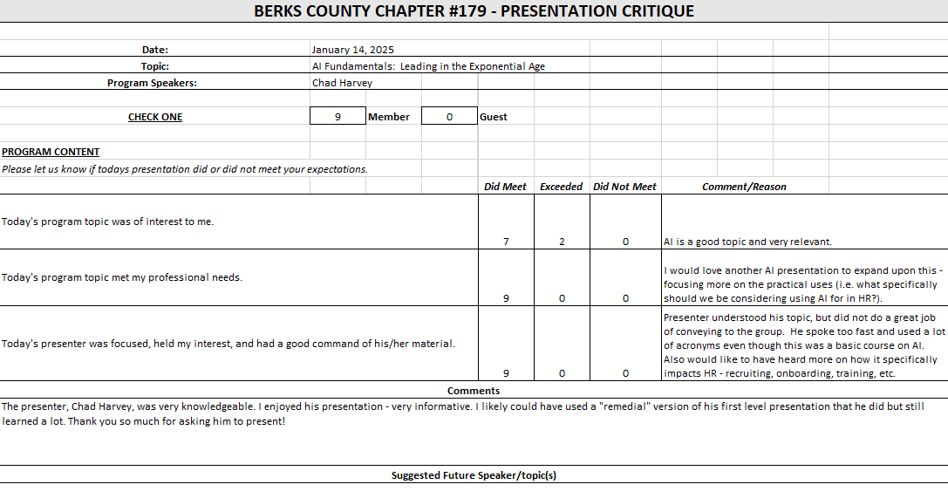

  - “Cumulative Trauma Disorders and Prevention” presented by Emily McKeon on January 28, 2025
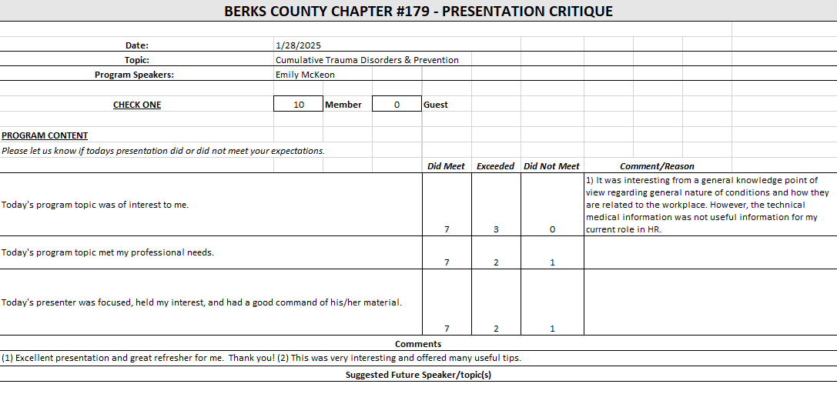

  - “Pay Transparency & Equity” presented by Karen DiGioia on February 11, 2025
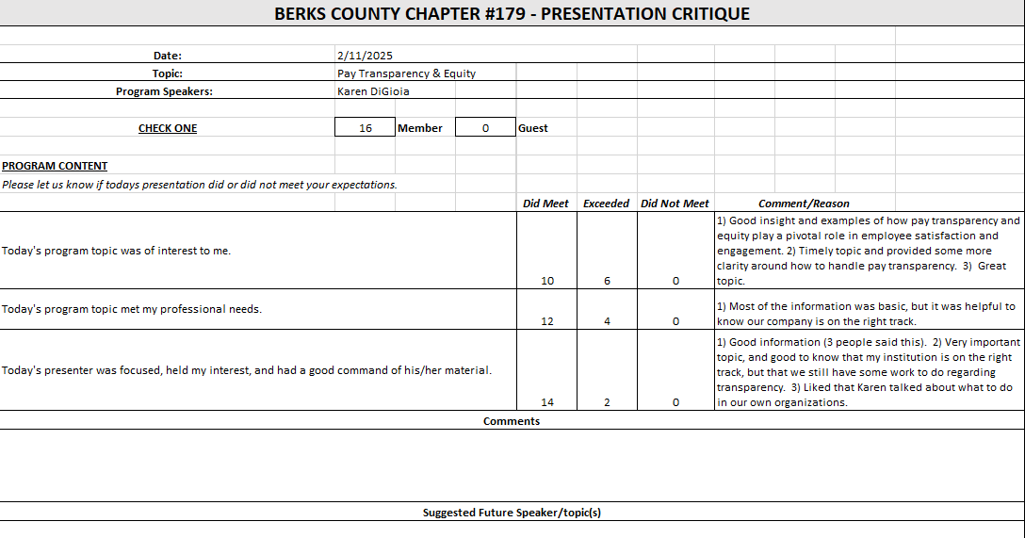

- Committees and Chair Reports:

- Administrator – Website (Wendy Button) Final stages of membership renewals; Will send out one more reminder to those who did not renew yet; To date, 70 members have not renewed yet.
- BCTV (Benjamin Lewis) Recorded DEI update session; Looking for “medical marijuana” as topic in May.
- Certification – Study Group (Ramona Wolf) Not present but Alyssa reminded everyone that they are looking for a new Certification Chair since Ro is stepping down after the Fall 2025 session.
- Chapter of the Year (Susan Kelly) Nothing to report.
- Compliance (Susan Kelly) Confirmed that she is finalizing compliance filings.
- DEI (Diversity, Equity & Inclusion) (Denise Lee) Not present.
- Engagement Committee/Marketing (Nic Thomas) January outing was a success; one new member did attend; Looking to schedule future events, suggested looking at different times of day to accommodate the different interests.
- Historian (Benjamin Lewis) Status is same, still working on gathering historical material.
- Membership (Nic Thomas) We had 2-3 new members in January which aligns with the monthly average; Looking to reach out to HR members who are new to the area.
- Legislative (Whitney Rahman) It has been a busy period Legislation wise; Since we are having virtual meetings, Whitney has been sharing the monthly Legislative Updates with Wendy who has been distributing them to meeting attendees.
- A-Team (Alex Goodman) No updates but did have a question regarding if her attendance was required at the May8th Legislative Conference; it is not required but it would be good for her to go if she is able; Also asked Wendy if she is connected to SHRM as the A-Team Chair, Wendy confirmed that she is.
- Programming / Speaker Contact (Krista Pauley) Krista confirmed that we have speakers through May; she is looking to fill 2025-2026 meeting slots; challenge is with Speakers requiring fees.
- Sponsorship / Business Networking (Tamara DeLoretta) Not Present
- Olivet Boys and Girls Club - PAL Dinner or RHS Initiatives (Debbie Ramsey) Not Present
- SHRM Foundation (chairperson needed)
- Old Business
  - Update on Chapter By-Laws review (Alyssa) Alyssa is waiting to hear from National regarding the status of the By-Laws review.
  - Liability insurance policy review (Cherie & Nic) Pending – new SHRM Affiliate Standards will impact decision.
    - $1,000,000 liability limit = $1,067/year premium
    - $500,000 liability limit = $872/year premium
  - ½ Day Workshop Suggestion (Krista, Denise, Tamara, and Alyssa) – Judy Umlas / DEI
    - Who can spearhead the planning for this event? Status is Pending
  - Credit Card Processing Company Review (Michael) Pending – No requirement to use bank’s system; Bank’s system has tools built-in which assists Chapter with compliance; If we switch, will it be difficult to build system to match what we need?; Do we want to find another option just to do a comparison?; We possibly are not large enough to get the best rates/programs; Nic mentioned he may have a contact who could possibly assist us with the research, Nic will put the contact in touch with Michael.
Cherie brought up past suggestion to pass credit card fees to members who use it.
Michael also brought up suggestion to put DEI funds into an account which earns interest; he will explore further with bank.
  - Updating job descriptions – added key events/conferences Alyssa is finalizing and will share with team once completed.
- New Business:
  - Certification Chair search Ongoing
  - PA SHRM State Council Q1 Meeting Notes
    - Requesting raffle donations (baskets) for the Legal & Legislative Conference in May Motion to approve basket donation with cost up to $100: Motion by Ben Lewis; 2nd Beth Shartle; No Questions; All in Favor
    - SHRM Affiliate Standards Program
      - Required: Dual Membership Requirements (President, Membership Director, Certification Director), basic Directors & Officers (~$840 annually), Errors & Omissions (~$750 annually), and Cyber Liability (~$500-$2,000 annually) insurance, completion of regular financial audits (every 3-5 years)
      - NOT Required: VLBM Attendance, SHRM Foundation donation VLBM provides a great deal of value to incoming VP and President; Michael is considering attending. SHRM Foundation Donation will continue if speakers the foundation; will not need to make up any difference at end of year.
      - Report is due 1/31/26 – need to be in compliance by then Target to be in full compliance in 2025.
      - Webinar will be held to provide additional information during 2nd/3rd week of March Alyssa will send out the info to the entire Board when received.
      - NEW – A question regarding “Audits” was presented; Chapter financial audits were done in the past every 3-5 years but have not been done in some time; Ben brought up idea that a group of members outside the Board conduct the audit as he has seen with other groups; This will need further review.
    - PA SHRM revenue sharing details
      - 2024: Attend 75% of state council meetings AND send 2 non-state council members to Volunteer Leadership Conference ($500 for completing both, $100 for completing one)
      - 2025: Attend 75% of state council meetings, send 2 non-state council members to Volunteer Leadership Conference, market PA SHRM conferences to Chapter, AND send 4 non-state council members to volunteer at PA SHRM conferences during the year Will costs of sending members to events outweigh any revenue sharing benefits?; Need to research further.
- Future Berks, PA and National SHRM meetings/dates:
* State Council meetings available to Executive Board, District Directors, Chapter Presidents and Core Leaders
* VLBM invitees: TBD, but most likely the 2026 Chapter President only. SHRM National covers cost of hotels, meals, and transportation between hotel/airport.
  - March 11, 2025 – General Meeting (Virtual) – 11:00 am to 12:30 pm – Harold Ford presenting “AI in HR 2.0: Shaping the Future of Work”
  - March 25, 2025 – Lunch & Learn (Virtual) – 11:30 a.m. to 12:30 p.m. – Eric Rodriguez (topic TBD – mental health)
  - May 7, 2025 – Q2 PA SHRM State Council Meeting - Camp Hill, PA - 1:00 pm – 5:00 pm
  - May 8, 2025 – PA SHRM Legal & Legislative Conference – Camp Hill, PA
  - June 28, 2025 – July 2, 2025 – SHRM Annual Conference – San Diego, CA
  - July 18, 2025 – Q3 PA SHRM State Council Meeting (Virtual) - 9:00 am – 11:00 am
  - July 25, 2025 – PA SHRM Volunteer Leadership Conference – Gettysburg, PA
  - September 10, 2025 – Q4 PA SHRM State Council Meeting – State College, PA – 1:00 p.m. to 5:00 p.m.
  - September 11-12, 2025 – Annual Conference – Penn Stater Hotel & Conference Center, State College, PA
  - November 20-23, 2025 – Volunteer Leaders Business Meeting (VLBM) – Cancun, Mexico
- Deadlines
  - March 15, 2025 – EXCEL Award (VP) Alyssa to share info with Cherie; process is “pretty straightforward”.
  - April 15, 2025 – Annual Statement – PA Dept. of State – Bureau of Corporations and Charitable Organizations – 990-N (e-postcard) to the IRS (Susan)
  - August 1, 2025 – Chapter of the Year (COTY) (Susan)
  - September 1, 2025 - Pinnacle Award Application
  - November 15, 2025 – Re-Certification Provider Reaffirmation Due (Chris)
  - December 1, 2025 – CLIF report (Wendy)
  - December 31, 2025 – SHRM Foundation annual donation (Treasurer)
  - January 31, 2026 – Deadline to issue 1099 (Treasurer to work with RKL)
  - January 31, 2026 – SHAPE (“SHRM Affiliate Standards Program”) report (VP)

- Next Board Meeting – March 18, 2025 – 7:30 to 9:00 a.m. via Teams

- Motion to adjourn Cherie Terrey; 2nd Beth Shartle @ 8:39 AM

